#include <bits/stdc++.h>
using namespace std;

int main(){
try{
int age = 15;
if (age >= 18){
cout << "Access Granted - you are old enough" << endl;

}else{
throw (age);
}

}
catch(int e){
cout << "There are errors.";
}

}

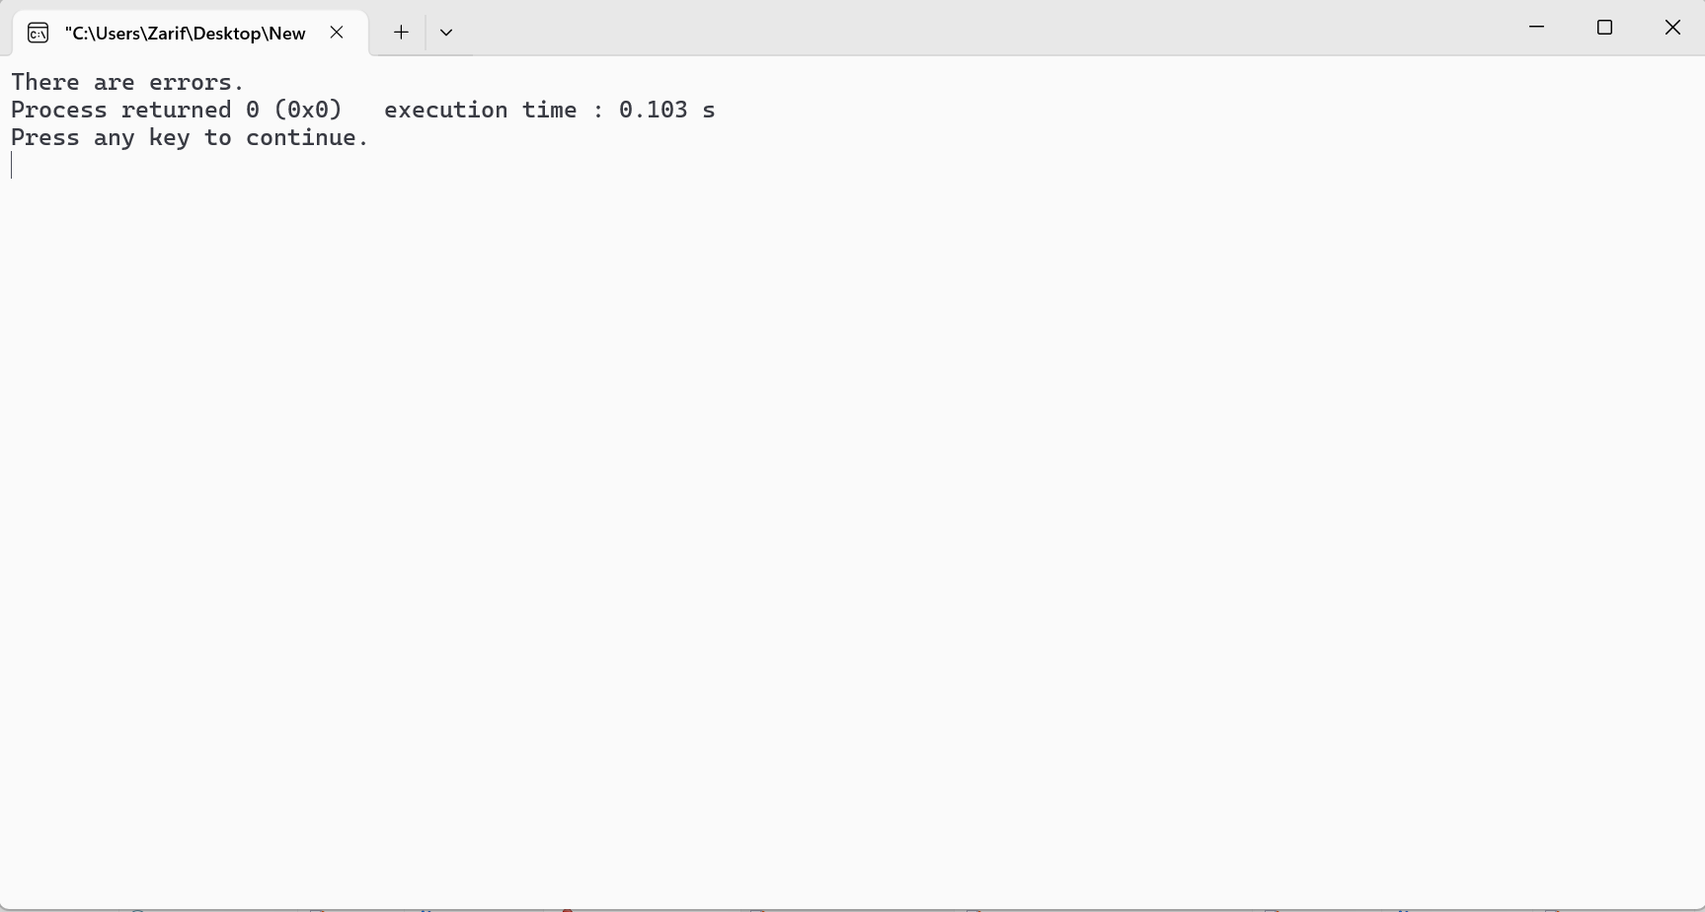

#include <bits/stdc++.h>
using namespace std;

int main(){
try{
int age = 15;
if(age>=18){
cout << "Access granted - you are old enough"<< endl;
}else{
throw 505;
}
}catch(int myNum){
cout << "Access denied - You must be at least 18 years old" << endl;
cout << "Error number:" << myNum << endl;
}
return 0;

}

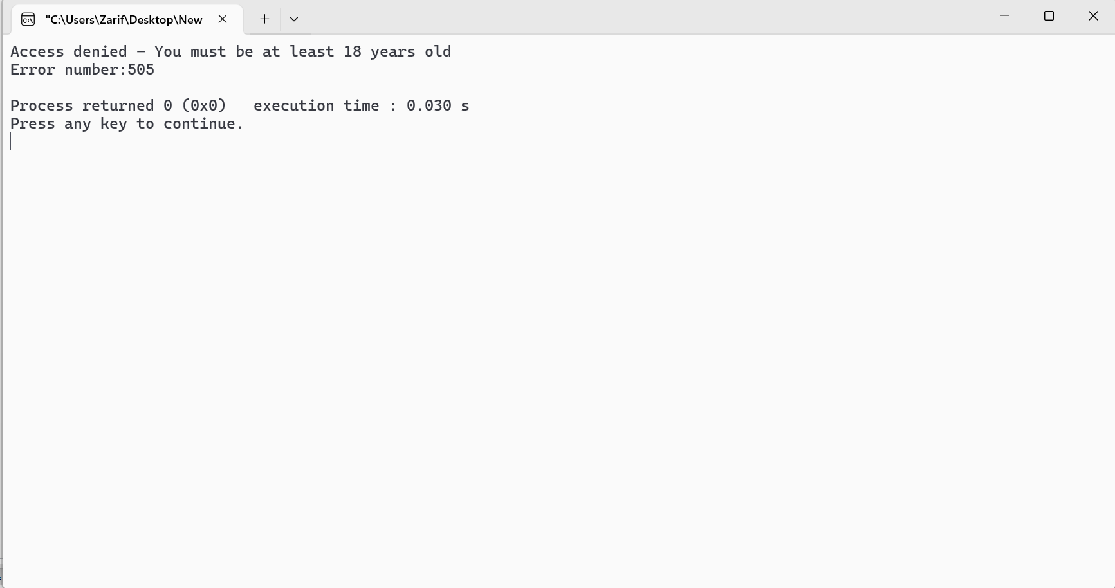

#include <iostream>
using namespace std;
int main()
{
try
{
int age = 15;
if (age >= 18)
{
cout << "Access granted - you are old enough.";
}
else
{
throw 505;
}
}
catch (...)
{
cout << "Access denied - You must be at least 18 years old." << endl;
}
return 0;
}

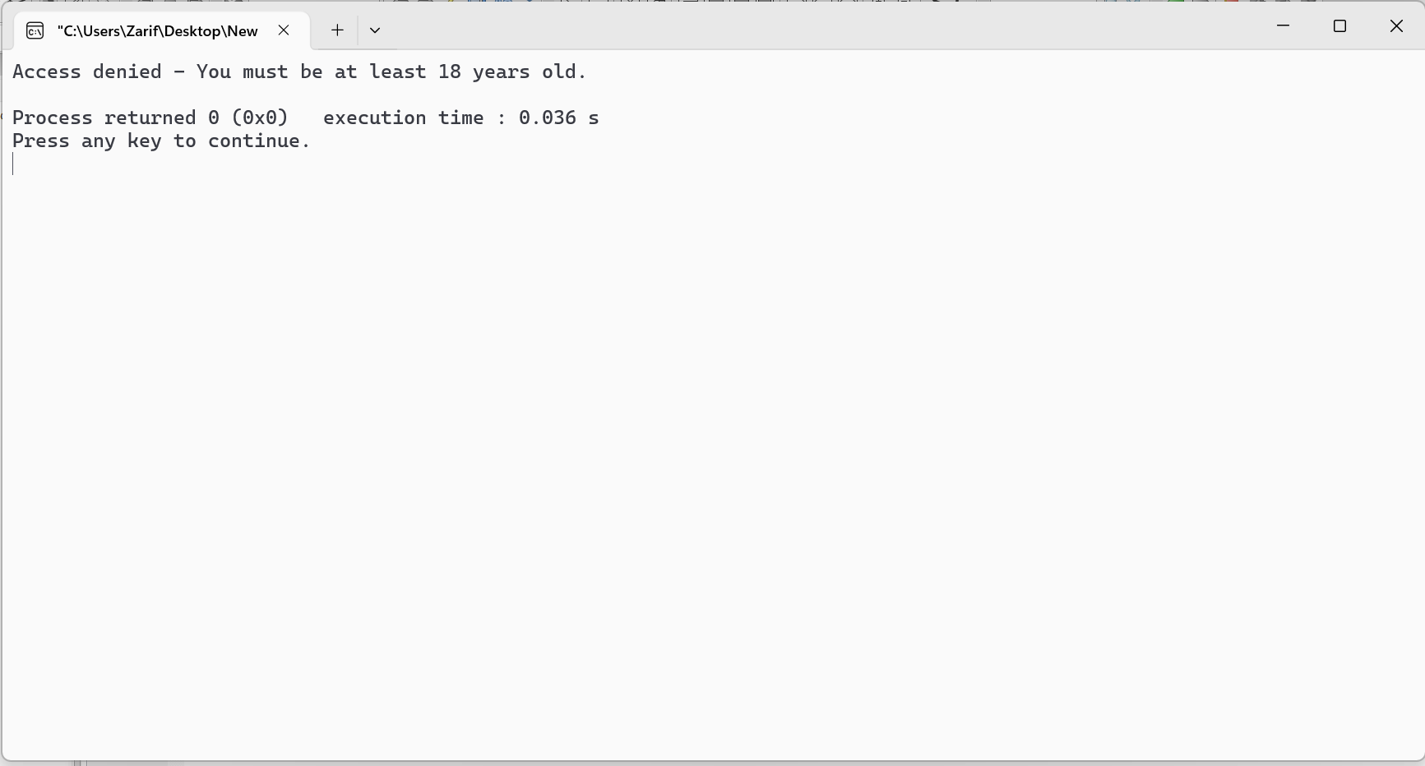

#include <iostream>
using namespace std;
int main()
{
// try block
try
{
// throw
throw 10;
}
// catch block
catch (char* excp)
{
cout << "Caught " << excp;
}
// catch all
catch (...)
{
cout << "Default Exception\n";
}
return 0;
}

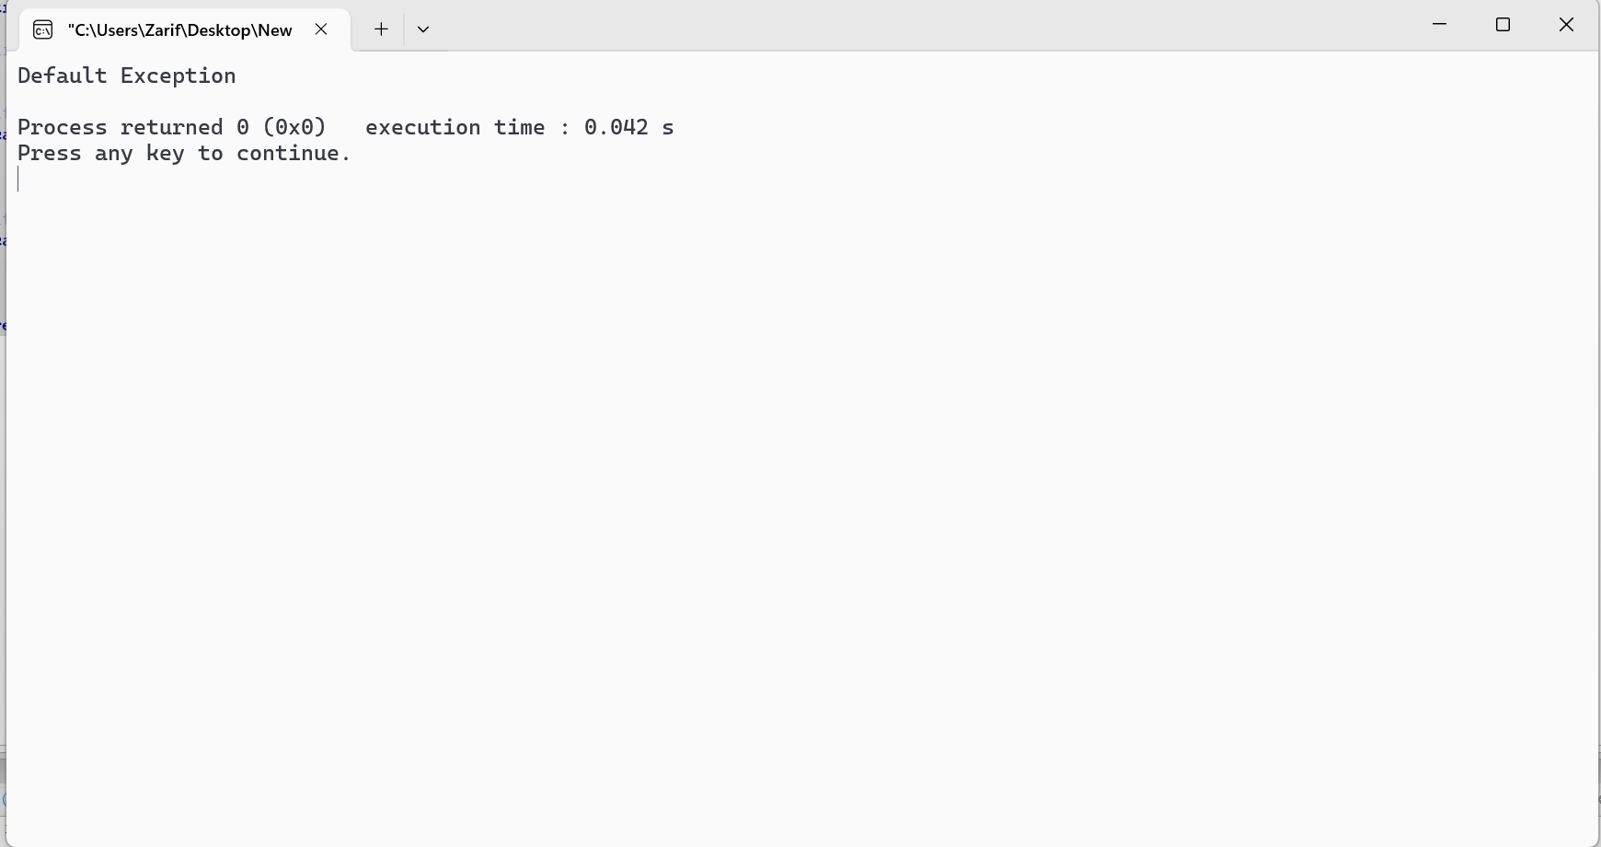

#include <iostream>
using namespace std;
int main()
{
double numerator, denominator, divide;
cout << "Enter numerator: ";
cin >> numerator;
cout << "Enter denominator: ";
cin >> denominator;
try
{
// throw an exception if denominator is 0
if (denominator == 0)
throw 0;
// not executed if denominator is 0
divide = numerator / denominator;
cout << numerator << " / " << denominator << " = " <<
divide << endl;
}
catch (int num_exception)
{
cout << "Error: Cannot divide by " << num_exception <<
endl;
}
return 0;
}

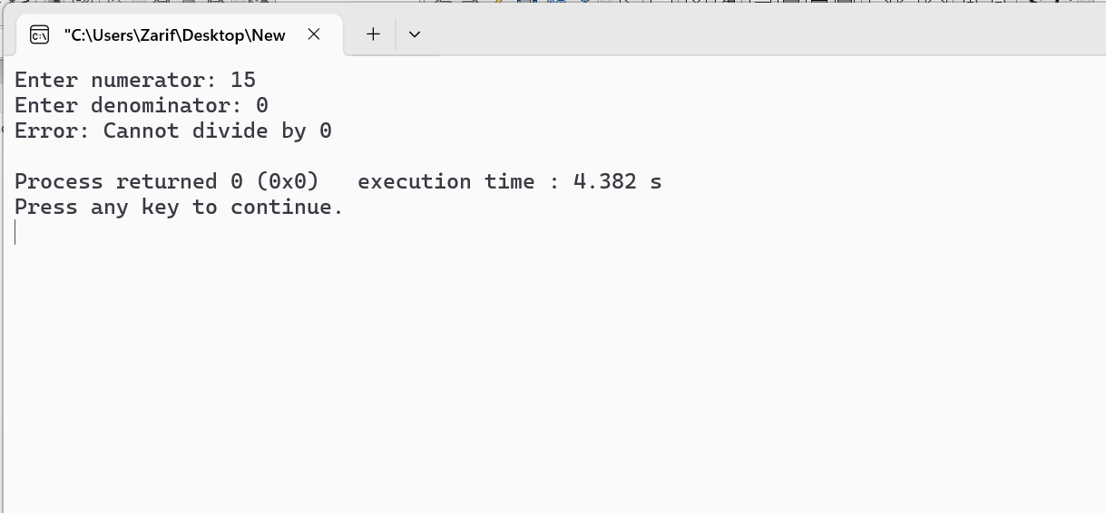

#include <iostream>
#include <stdexcept> //Defines several standard classes used for reporting exceptions.

using namespace std;
int main()
{
// try block
try
{
int numerator = 10;
int denominator = 0;
int res;
// check if denominator is 0 then throw runtime
// error.
if (denominator == 0)
{
throw runtime_error(
"Division by zero not allowed!");
}
// calculate result if no exception occurs
res = numerator / denominator;
//[printing result after division
cout << "Result after division: " << res << endl;
}
// catch block to catch the thrown exception
catch (const exception& e)
{
// print the exception
cout << "Exception " << e.what() << endl;
}
return 0;
}

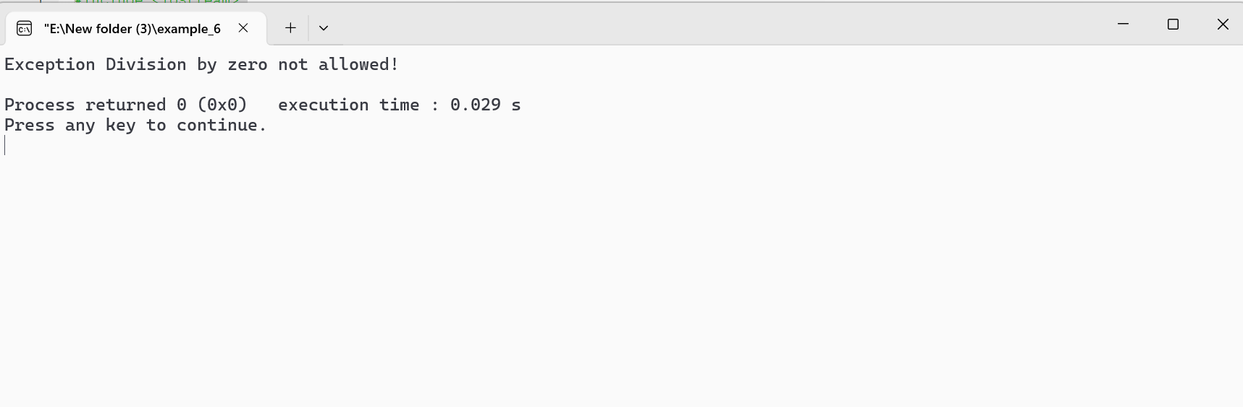

#include <iostream>
#include <exception>
using namespace std;
class MyException : public exception
{
public:
const char * what() const throw()
{
return "Attempted to divide by zero!\n";
}
};
int main()
{
try
{
int x, y;
cout << "Enter the two numbers : \n";
cin >> x >> y;
if (y == 0)
{
MyException z;
throw z;
}
else
{
cout << "x / y = " << x/y << endl;
}
}
catch(exception& e)
{
cout << e.what();
}
}

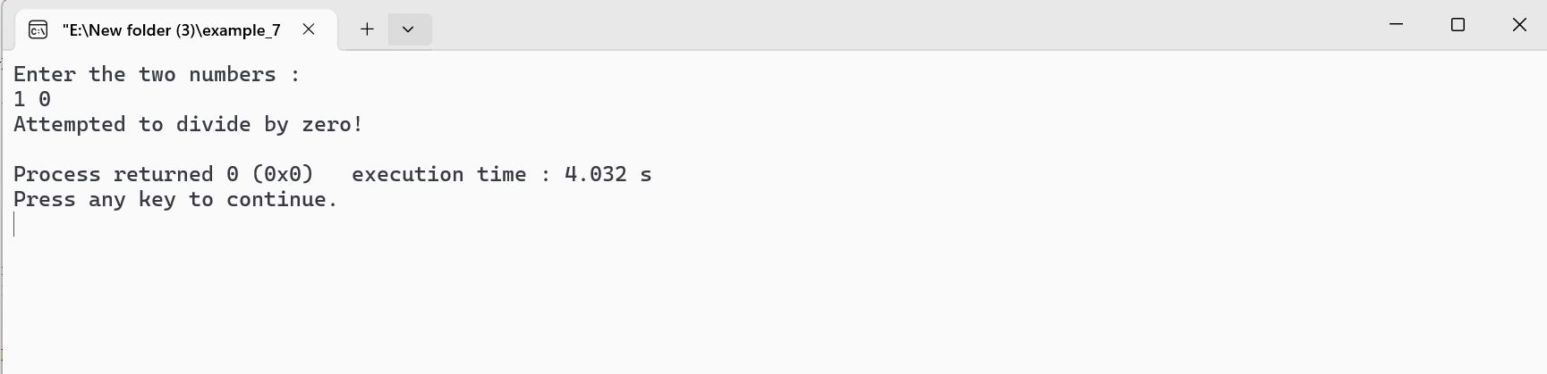

#include <iostream>
using namespace std;
int main()
{
int x = -1;
// Some code
cout << "Before try \n";
// try block
try
{
cout << "Inside try \n";
if (x < 0)
{
// throwing an exception
throw x;
cout << "After throw (Never executed) \n";
}
}
// catch block
catch (int x)
{
cout << "Exception Caught \n";
}
cout << "After catch (Will be executed) \n";
return 0;
}

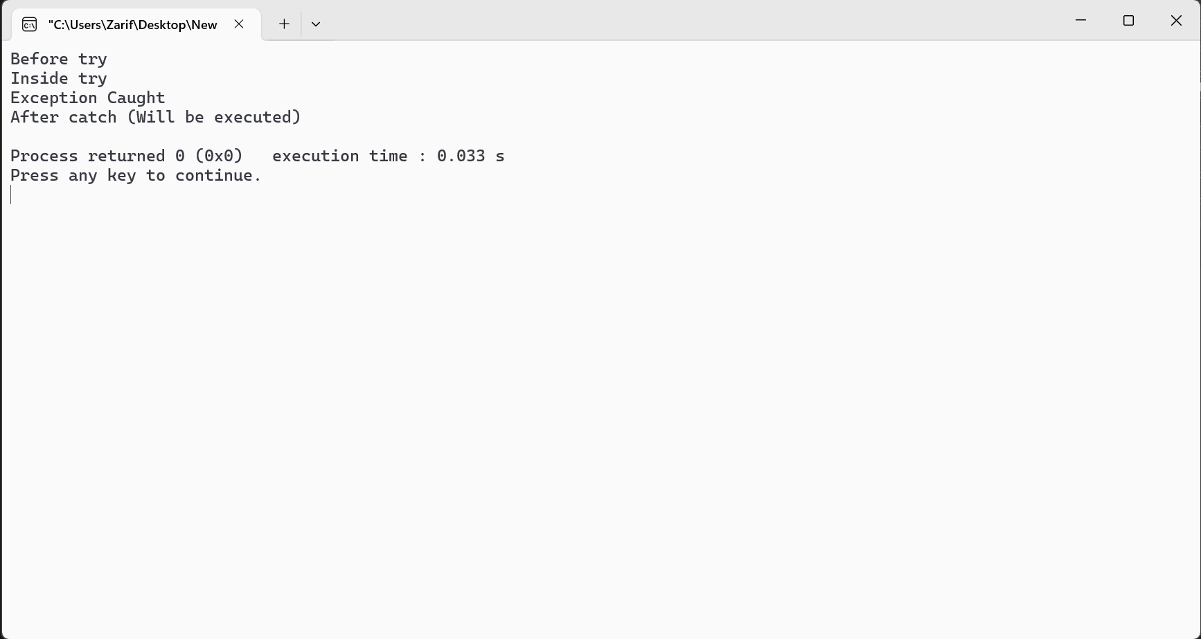

#include <iostream>
using namespace std;
int main()
{
double numerator, denominator, arr[4] = {0.0, 0.0, 0.0, 0.0};
int index;
cout << "Enter array index: ";
cin >> index;
try
{
// throw exception if array out of bounds
if (index >= 4)
throw "Error: Array out of bounds!";
// not executed if array is out of bounds
cout << "Enter numerator: ";
cin >> numerator;
cout << "Enter denominator: ";
cin >> denominator;
// throw exception if denominator is 0
if (denominator == 0)
throw 0;
// not executed if denominator is 0
arr[index] = numerator / denominator;
cout << arr[index] << endl;
}
// catch "Array out of bounds" exception
catch (const char *msg)
{
// Notice the catch parameter const char* msg. This indicates that the catch statement takes a string literal as an argument.
cout << msg << endl;
}
// catch "Divide by 0" exception
catch (int num)
{
cout << "Error: Cannot divide by " << num << endl;
}
// catch any other exception
catch (...)
{
cout << "Unexpected exception!" << endl;
}
return 0;
}

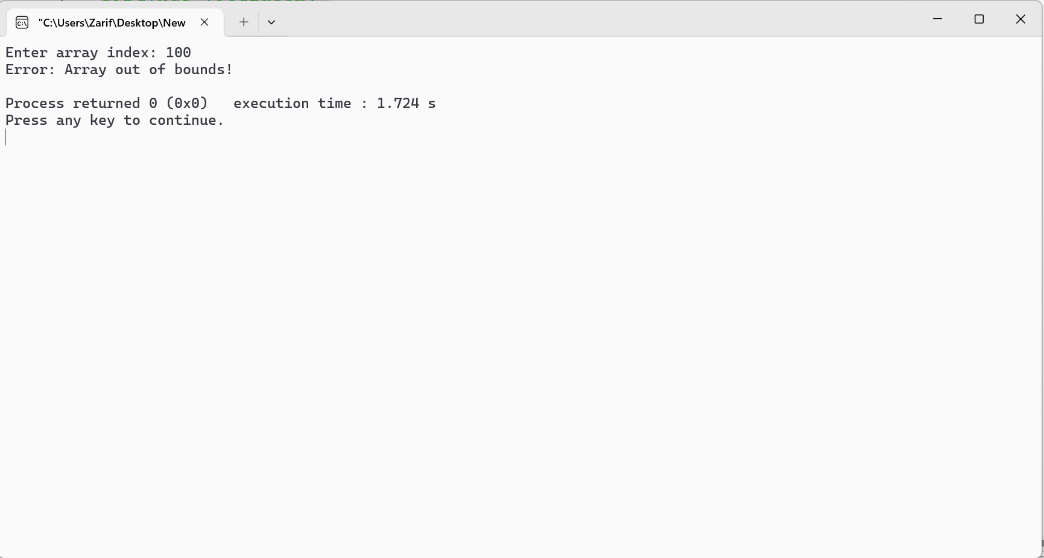

#include <iostream>
using namespace std;
int main()
{
// nesting of try/catch
try
{
try
{
throw 20;
}
catch (int n)
{
cout << "Handle Partially ";
throw; // Re-throwing an exception
}
}
catch (int n)
{
cout << "Handle remaining ";
}
return 0;
}

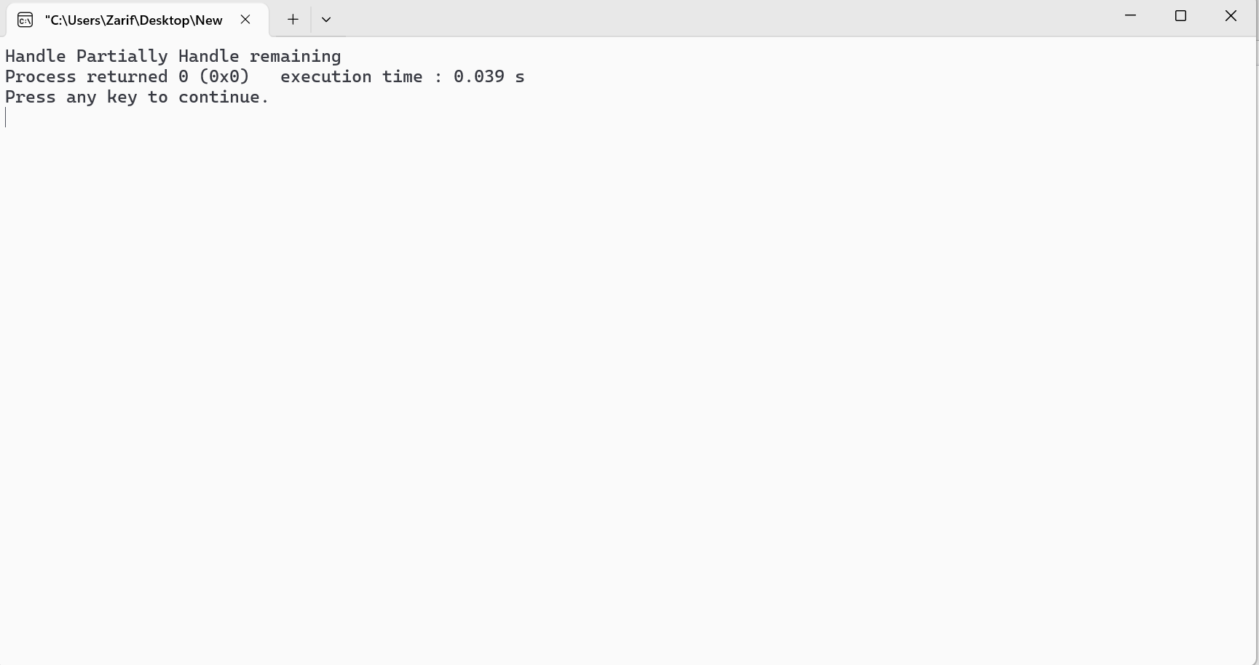

#include <iostream>
using namespace std;
int main()
{
try
{
throw 'a';
}
catch (int x)
{
cout << "Caught ";
}
return 0;
}

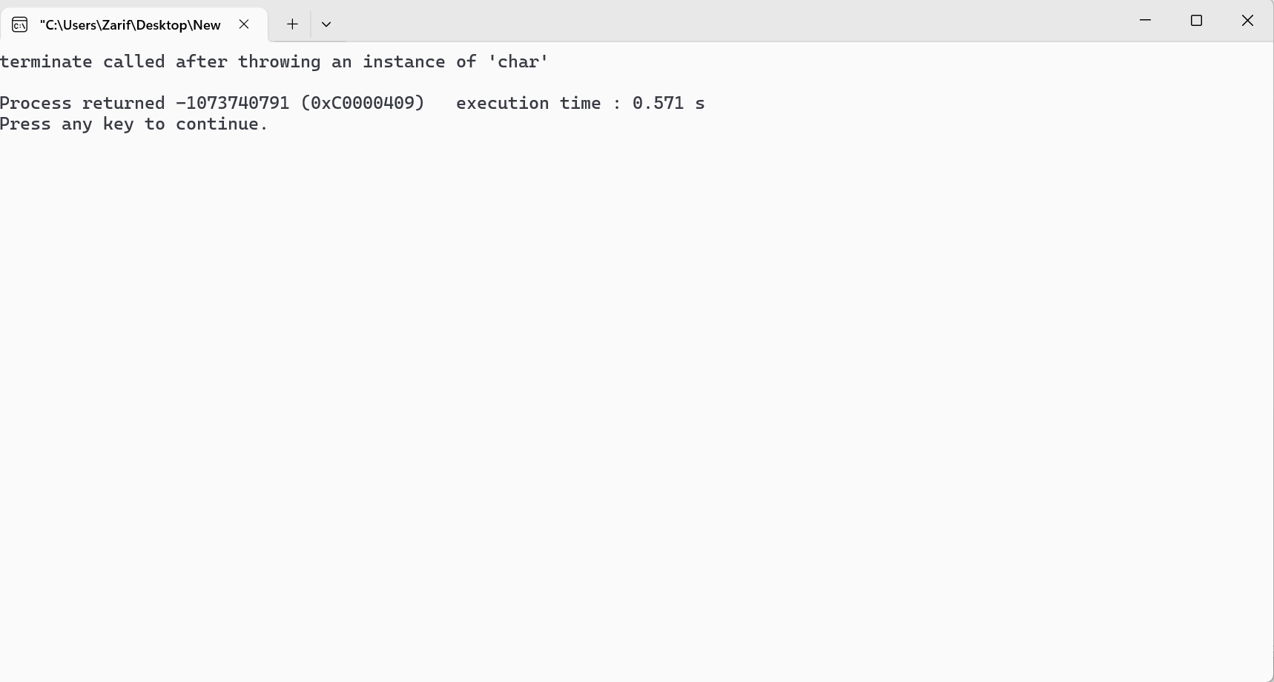

#include <iostream>
using namespace std;
// Define a class named Test
class Test
{
public:
// Constructor of Test
Test()
{
cout << "Constructor of Test " << endl;
}
// Destructor of Test
~Test()
{
cout << "Destructor of Test " << endl;
}
};
int main()
{
try
{
// Create an object of class Test
Test t1;
// Throw an integer exception with value 10
throw 10;
}
catch (int i)
{
// Catch and handle the integer exception
cout << "Caught " << i << endl;
}
}

